Date : 31.03.2020 11th grade Lesson 1A Self assessment
Aims of the lesson: to improve pupils’ awareness of self evaluation, importance of self-esteem; assessing others
- Activity 1.
Pupils match the ways of how to stop plagiarizing from the box with the suitable pictures.
Answer key: 1. Diary 2. Planning timetable 3. Self-assessing pictures
Activity 2 Pupils match the words from the box with their definitions.
  - Doing tasks without involving other people
  - Make something new
  - To tell somebody that you like or admire something they have done
  - A thing or fact that is found for the first time
  - To look again at work that you have done
  - Impossible to believe
  - The whole
  - To recognize somebody or something
  - The process of judging your own progress,achievements
  - Connected with real situations rather than with ideas or theories
Answer key: 1. self-directed 2. to create 3. to compliment 4. Discovery 5. to revise 6. Incredible 7. entire 8. Identify 9. self-assessment 10. practical
Activity 3. 3 Pupils. listen to the tape and fill in the gaps.
Teacher 1: Learners themselves. It’s incredible that my students
so much. Student 1: Take your time for a . You your mistakes Student 2: Tell yourself what you did and . yourself. Teacher 2: The most important thing was to learners. Self-direction feeds their life.
Answer key : 1. Teacher 1: make decisions, improve 2. Student 1: self-assessment, realize 3. Student 2: wrong and right, compliment 4. Teacher 2: create independent, entire
Activity 4. Pupils Listen to the tape again and fi nd word-associations to the given words in the pictures.
Answer key : Learning-growth Question- Answer Self-assessment - Help students to identify strength and weaknesses, independent, self-directed, life-long learners.
Homework pupils make a list of vocabulary which you have learned today

Date : 1.04.2020 11th grade Lesson 1A Self assessment
Aims of the lesson: to improve pupils’ awareness of self evaluation, importance of self-esteem; assessing others

Activity 5.Pupils read the self-assessment tool and match the words in italics in the sentences and the pictures with their synonyms below.
I am just starting to learn this and I do not a) comprehend it yet. b) I can do this if I get c) assistance or look at an d) instance. I can do this on my own without help.
I can do this independently and can f) explain others how to do it.
Use the Learning g) Target Self-Assessment given above and h) evaluate yourself in earning process

Activity6. Pupils read the self-assessment tool again and decide whether the statements below are Novice (N), Apprentice (A), Practitioner (P) and Expert (E).
Answer key: 1. Expert 2. Apprentice 3. Practitioner 4. Novice 5. Apprentice 6. Expert 7. Novice 8. Apprentice
Activity 7. Pupils look at the table given below. Assess your current level of the given subjects.
Homework. Make a list of vocabulary, which you have learned today. Assess your family members, classmates and teachers.by using a tool of exercise 7. Write a descriptive essay about your Learning process at school.
Date : 4.04.2020 11th grade Lesson 1B Self assessment
Aims of the lesson: to improve pupils’ awareness of self evaluation, importance of self-esteem; assessing others
Activity 1. Pupils ake affirmative present perfect sentences.
  - (I / study / French) 2. (She / eat / octopus) 3. (They / go / to Scotland) 4. (We / read / that book) 5. (He / live / here for three years) 6. (You / know / David for ten years) 7. (We / be / here for two weeks) 8. (I / lose / my keys) 9. (He / drink / too much coffee) 10. (They / miss / the train)
Present Perfect
1: We use this tense when we want to talk about unfi nished actions or states or habits that started in the past and continue to the present. Usually we use it to say ‘how long’ and we need ‘since’ or ‘for’. We often use stative verbs.
1. I’ve known Karen since 1994. Have you known her since 1994? 2. She’s lived in London for three years. She hasn’t lived in London for three years. Has she lived in London for three years? 3. I’ve worked here for six months.
Answer key : 1.I have studied French. 2. She has eaten octopus. 3. They have gone to Scotland4. We have read that book. 5.He has lived here for three years. 6. You have known David for ten years. 7. We have been here for two weeks. 8.I have lost my keys. 9. He has drunk too much coffee. 10. They have missed the train.
Activity 2. Pupils make negative and interrogative present perfect sentences.
Answer key: 1. We haven’t gone to Urgench. 2. She hasn’t seen “The Lord of the Rings” 3. He hasn’t met my mother. 4. They haven’t visited Bukhara. 5. I haven’t known him for three months. 6. You haven’t studied English for ten years. 7. They haven’t been in Tashkent for six months. 8. He hasn’t hurt his leg. 9. She hasn’t left her phone in a taxi. 10. We haven’t lost our tickets. 11. Have they gone to Kazakhstan? 12.Have you read “War and Peace”? 13.Has she been late for a meeting? 14. Has he met your family yet? 15. Have they lived here as long as we have? 16. Have you gone to Termiz? 17. Has she missed the bus? 18. Have I met you before? 19.Have they taken the exam? 20. Has she worked in this company for fifteen years?
Activity 3. Pupils answer the questions about you. Use the present perfect in your answers.
1. How many countries have you travelled to? 2. What interesting food have you eaten? 3. Which famous person have you seen? 4. Where have you lived? 5. What language have you studied?

Homework. Pupils make a list of vocabulary, which they have learned today.
.
Date : 7.04.2020 11th grade Lesson 1B Self assessment
Aims of the lesson: to improve pupils’ awareness of self evaluation, importance of self-esteem; assessing others

Activity 5. Read the text again and match the words you have underlined to the following defi nitions.
Answer key: 1.Self-conscious 2. Mentally 3. Thought 4. Prevent 5. Social 6. Disapprove 7. Judge 8.Considerable 9. Inadequate 10. Incompetent
. Activity 6. Pupils look at the pictures. Find the most effective good mood products and write them.
Answer key : 1. Dark chocolate 3. Green tea 5. Eggs 2. Almonds 4. Banana 6. Orange
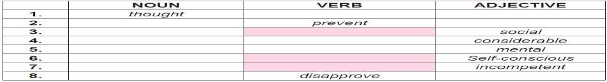
Activity 7. Word building. Pupils complete the table.

Activity 8. Pupils look at the picture. And answer the following questions.
How do you evaluate your self-esteem? Whom do you know with self-esteem?
Homework. Pupils make a list of vocabulary which you have learned today. Write a narrative essay: “The best life experience I have ever had”. (100 – 120 words)

______________________________________________________________________________
Date : 9.04.2020 11th grade Lesson 2A The role of feedback
Aims of the lesson: to improve pupils’ awareness of the role of feedback and its imortance in learning

Activity 1. Pupils label the pictures with the expressions from the box.
Answer key: 1. Teacher’s feedback 2. Positive feedback 3. Peer feedback 4. Negative feedback

Activity2. Pupils match the words and phrases with their definitions
Answer key: 1. D 2. H 3. A 4. B 5. F 6. К 7. E 8. С 9. 10.G 11.M 12.I

Activity 3. T.18. 3. Pupils listen to the tape and fi ll in the gaps.
1. What is a powerful way to enhance teaching and learning? 2. Who can you receive feedback from? a) b) c) 3. What kind of models for giving feedback have Hattie and Timperley developed? 4. What kind of questions do ’the models
of giving a feedback’ propose? a) b) c) 5. Which goals help the students
succeed and grow? 6. According to the evidence, what are the students’ knowledge, skills and performance connected with?
Answer key : 1. Feedback 2. Teacher, peers, the student himself 3. Two-evidence based 4.1) Where is the learner going? 2) Where is the learner right now? 3) How does the learner get there? 5. Challenging 6. learning goals and tasks
Homework. Pupils make a list of vocabulary which you have learned today.

Date : 11.04.2020 11th grade Theme: Revision
Aims of the lesson: revise all materials learnt on previous lesson; raise awareness of good learning habits

Activity 1. Pupils look at the photos and guess the situations
Who are they? Where are they? What are they doing?
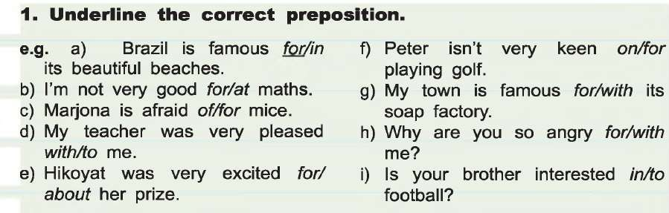
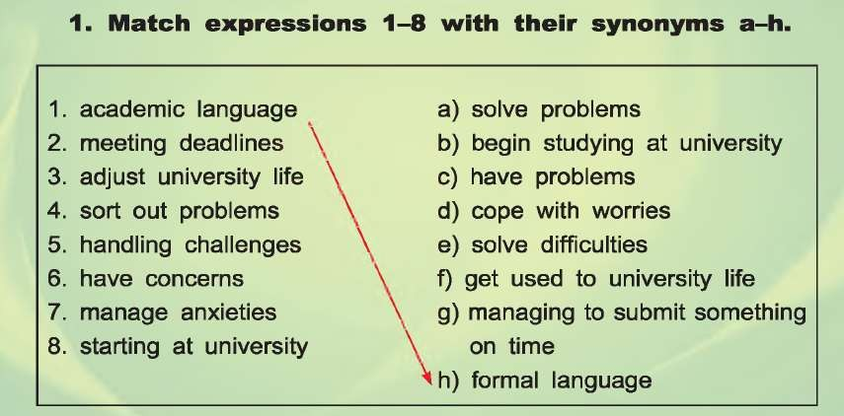
Homework. Pupils make a list of vocabulary which they have learned today.

_________________________________________________________________________________________

Date : 14.04.2020 11th grade Lesson 2A The role of feedback
Aims of the lesson: to improve pupils’ awareness of the role of feedback and its imortance in learning

Activity 5. Pupils read the passage and match the words in italics to their definitions below.
Giving and Receiving Feedback
- What is feedback?
It is helpful informaton or criticism that is received or given to an individual to say what can be done to improve a performance or product. Most effective when it is timely, perceived as relevant, meaningful and encouraging, and offers suggestions for improvement that are within a receiver’s grasp. Feedback is a process by which it communicates to people something about their behavior, output, work, attitude.

Answer key : 1. Defensive 2. Appreciation 3. Judgmental 4. Relevant 5. Impact
6. Observation

Activity 6 Pupils read the article again and decide whether the statements below True (T) or False (F).
1. Feedback should include supportive information. 2. Feedback can be positive or affi rming.
3. General feedback is not effective. 4. Encouragement is the fi rst stage of giving feedback. 5. The students, who do not want to upset others, avoid giving Feedback
Answer key. 1. False 2. True 3. False 4. True 5. False 6. True

Homework. Pupils make a list of vocabulary, which they have learned today. And Make a report about “Giving and receiving feedback”.

Date : 16.04.2020 11th grade Lesson 2B The role of feedback
Aims of the lesson: to improve pupils’ awareness of the role of feedback and its imortance in learning

Activity 1. Pupils make affirmative present perfect continuous sentences.

Answer key: 1. She has been working here for five years. 2. I have been studying all day. 3. You have been eating 4. We have been living 5. He has been playing 6. They have been learning 7. I have been cooking 8. She has been going 9. It has been raining 10. You have been sleeping 11. I haven’t been working 12.You haven’t been eating 13. We haven’t been exercising 14. She hasn’t been studying
15.They haven’t been living 16. It hasn’t been snowing 17. He hasn’t been playing 18. We haven’t been drinking 19.I haven’t been sleeping 20.They haven’t been watching

Activity 2. Pupils write down the sentences with Present Perfect Simple or Present Perfect Answer key. 1. Have they arrived already? 2. Gulnora has run 2000 metres today. 3. I’ve been cleaning all morning - I’m fed up! 4. How long have you known Nilufar? 5. I’ve been drinking more water lately,
and I feel better. 6. Sony about the mess! I’ve been baking. 7. How many times have you taken this exam? 8. He has eaten six bars of chocolate today! 9. Zuhra has cooked dinner. Let’s go and eat! 10. The students have finished their exams. They’re very happy.
Activity 3. Pupils make up sentences with Present Perfect Simple or Present Perfect Continuous.
Answer key : 1. Have you bought your train ticket yet? 2. The kitchen is a complete mess! What have the children been doing? 3. Aydin has been learning to drive for six years! 4. Gulnora hs already had lunch, so shell meet us later. 5. How much coffee has she drunk this morning? 6. Nurdaulet has written three books.
Activity 4. Pupils scan the text below and underline the following words.
Homework. Pupils make a list of vocabulary which they have learned today.
_____________________________________________________________________________________
Date : 18.04.2020 11th grade Lesson 2B The role of feedback
Aims of the lesson: to improve pupils’ awareness of the role of feedback and its importance in learning

Activity 5. Pupils read the text again and match the words you have underlined to the following definitions.
A task or piece of work that somebody is given to do 2. To form an opinion of something after thinking about it carefully 3. The student, who has lessons online 4. An idea
5. Advice, criticism about how good somebody’s work is 6. To become better than before

7. To make something understandable 8. A short statement giving only the main points of something 9. A plan 10. A period of time that is spent on doing a particular activity

Answer key : 1. Assignment 2. Evaluate 3. Distance learner 4. Suggestion 5. Feedback
6. Improve 7. Clarify 8. Summary 9. Concept 10. Session

Activity 6. Pupils look at the pictures of types of giving feedback from the box and write them
Answer key : 1. Oral 2. Electronic 3. Group 4. Peer 5. Meeting 6. written Activity 7. Word building. Complete the table
Answer key:
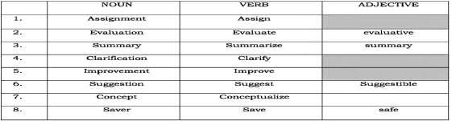

Homework. Pupils make a list of vocabulary which you have learned today. � and watch one presentation about any topic in English and write feedback according to the following criteria. (100 – 150 words). Using the “Present Perfect Continuous”, words and phrases they have learned today.

Date : 20.04.2020 11th grade Theme: Revision
Aims of the lesson: revise all materials learnt on previous lesson; raise awareness of good learning habits

Activity 1. Pupils do these exercises

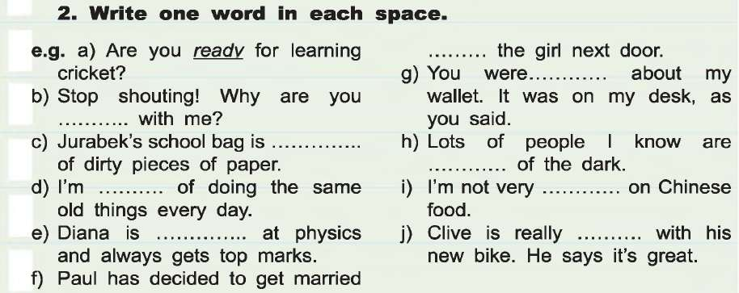

Homework. Pupils make a list of vocabulary which they have learned today.

Date : 20.04.2020 11th grade Lesson 1A The preparation
Aims of the lesson: to improve pupils’ awareness of student life; short and long term goals
Activity 1. Pupils label the picture s about the student’s life with the expressions from the box.
Answer key.1.Excursion with coursemates 3. Examination2. Scholarship4. Supervisor
Activity 2. Pupils label the words with their definitions from the box.
1.To learn a lot of things in a short time, in preparation for an exam 2. Being able to think and understand quickly 3. A school or university year 4. To emphasize or give something more attention 5. Timetable 6. To look again at something you have re ad or studied 7. Involving a lot of work or activity done in a short time 8.A way of doing a task 9.To change something to a more general or simple form 10.Alwaysbehavinginthesameway, or having the same opinions
Answer key: 1. to cram2. Nimble 3. Session 4. to highlight 5. Schedule 6. to review 7. Intensive
8.Approach 9. to reduce 10. consistent

Activity 3. T.19. 3.Pupils listen to the tape and fill in the gaps
Answer key: 1. Crammed, session 2. Reduce 3. Schedule 4. Review 5. Consistent 6. Highlight
7. Approach 8. Nimble

Activity 4. Write sentences the following timetable with your partner.

Homework. Pupils make a list of vocabulary which they have learned today

